

PROJECT REPORT

Intelligent solar generator for Cubesat

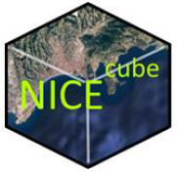

**Camille BRUNIN and Romain COCOGNE**

Electronic Department, 4th year

Polytech Nice-Sophia

Acknowledgments

First of all, we would like to thank our project tutor, M. Florentin MILLOUR, for his time, patience and cheerfulness.

Thanks to M. Olivier PREIS too for having brought us to the observatory, it was a really rewarding experience.

Finally, thanks to M. JACOB and M. LANGELLA for their help and educational support.

Summary

**INTRODUCTION** **4**

**SPECIFICATIONS** **5**

OBJECTIVES 5

SOLUTIONS 5

SENSORS 5

MICROCONTROLLER 7

SOLAR CELLS 7

**ESTIMATED BUDGET** **9**

**ARCHITECTURE** **11**

A- Block Diagram 11

B- Description 11

The solar panel 11

The sensors 11

The microcontroller 12

The alimentation 12

**ORGANIZATION** **13**

A- Tasks description 13

B- Tasks repartition 13

**BOM** **14**

# INTRODUCTION

NiceCube is a nanosatellite project that will allow the Lab Lagrange to do technological demonstrations by performing optical communications between earth and the satellite.

A satellite can be powered by different types of generators. First, solar energy is often the most exploited, by putting solar panels. This is how NiceCube will power energy, but we could also use nuclear energy or batteries, which would create different problems such as security problems for RTG (Radioisotope Thermoelectric Generator), or lifetime ones for the batteries.

Our mission is to conceive from scratch a solar panel that will be able to power the whole satellite. It will be used as a solar generator, but also will be able to give us useful real-time information about the satellite. Indeed, we will need to measure the current and voltage output of the solar panel but also it’s temperature, the sun location, and the earth horizon orientation, to know the satellite orientation. Moreover, the solar cells will need to be electrically protected and individually deactivated if damaged.

# SPECIFICATIONS

## OBJECTIVES

This project is about developing and testing a functional solution for a solar panel. The solar panel will be integrated into the surface of the NICEcube.

The panel needs to know in real-time the state of the solar cells and should be able to locate the satellite relative to the earth and the sun.

To do that, the panel needs to embed an ultra-low-power microcontroller connected to a bunch of sensors.

The panel will be separated into two main parts: the solar generator encompassing the solar cells and power electronics, and the control part encompassing the microcontroller and sensor environment.

## SOLUTIONS

### SENSORS

Solar sensor

We need to sense the satellite’s orientation compared to the sun. Knowing the required angle precision between the satellite and the antenna are 10°, the sensor needs a 3° precision in the worst case. The technology used is a masked one-dimensional PSD (depth of the mask is 1.5mm), so the corresponding length precision of the diode is 78um maximum.

The S3274-05 model gets a 35um maximum precision, which is under the specification. This PSD needs an under 300um wide light ray. The R1DS3N mask got a 10um wide strip line.

Magnetometer

We need to measure the satellite’s inclination compared to the earth’s surface. We will use a magnetometer to sense the earth’s magnetic field.

As the solar sensor, we need a 3° precision in the worst case.

Knowing the earth’s magnetic field of 05Gauss, we found a maximum error of 26mGauss.

The LSM9DS1’s precision is 0.14mGauss for 4Gauss magnetic fields and under. This corresponds to a 0.02° error. We are well under the specifications.

Horizon sensor

We need another vector to angle the satellite compared to the earth, so we need to use a horizon sensor. Just like the other sensor, this one needs a 3° precision in the worst case.

The MLX90641 is a 16x12 pixel thermal camera with a field of view of 110°, giving us a 9°/pixel precision. It means we have a 2.6° precision in the camera.

Although we can use this camera, a further test needs to be done to see if we are not under the 3° error. If that’s the case, we will use the more power costly 32x24 pixels camera.

Temperature sensor

This is needed to control the panel’s temperature. We can put a sensor in the center of the panel and another sensor opposite to the microcontroller to check if there is no overheating. There is no need for a big precision, as we want to measure big temperature variation. A 1°C precision is enough for us. The PCT2075 got a 1°C precision.

Voltmeter

We need to measure the volt variation (drop and pic) to check the state of our solar cells. We will use the analog pin of our micro-controller, with a max voltage input of 3.3V. To get maximum precision over the measurement, we take the voltage reference at 1.15V.

To make a voltage reference, we need to use a Zener Diode. As there is no Diode with a Zener voltage under 1.8V, we take 1.8V as a reference. With this, we can detect a voltage drop under 2V, which is enough to detect one solar cell’s failure.

Amperemeter

To complement the voltage measurement, we need a current variation measurement. We will use resistors in series with the solar cells and measure the resulting voltage. As the solar cells current is around 14mA, the analog pin of our microcontroller will be enough to detect a current drop.

### MICROCONTROLLER

The microcontroller needs to manage the sensor network and control the well-being of the solar cells. It needs to embed the I²C protocol because each sensor uses this communication protocol. It must have at least 6 analog pins for current and voltage measurements. It also needs to be optimized for calculations.

There are some non-quantitative requirements on energy consumption, reliability, and magnetism protection.

The MSP430FR59XX family responds to all the requirements.

### SOLAR CELLS

The system needs to be compatible with the CubeSat, meaning a 10x10cm² surface with truncated angles.

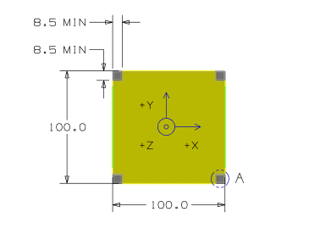

<https://static1.squarespace.com/static/5418c831e4b0fa4ecac1bacd/t/56e9b62337013b6c063a655a/1458157095454/cds_rev13_final2.pdf>

The yellow plane above is the available space for our system.

We will use TrisolX solar cells.

Each one is approximately 2.6cm². We use a 5mm margin around each cell. Considering the cells will be using 60% of the total panel surface, we can place a total of 12 cells onto our panel.

After testing, the ratio will be adjusted and more panels will be added, but for the prototype, this ratio will be enough.

The batteries’ control system is GOMSpace, nanopower p31u. As stated in the datasheet, we need to deliver between 4.2V and 8.5V. Knowing the cells are 2.33V max each, we will put 4 cells in series to deliver the correct voltage. As we can use 12 cells, we will make a 4x3 cell matrix.

To protect each line, we put a Schottky diode in series with the 4 cells.

# 

# ESTIMATED BUDGET

We were able to estimate the budget by taking into account all of the factors as if we really started this project from scratch. First, we estimated our salaries as engineers and our tutor’s salary. It gave us a total of 6 007€.

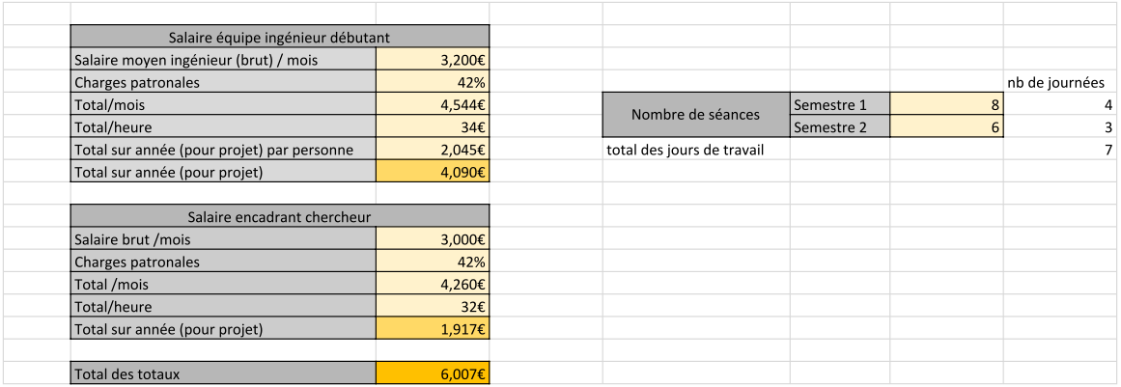

Then, we estimated the travel costs for us and our project tutor, which led us to a total of 1 299.96€.

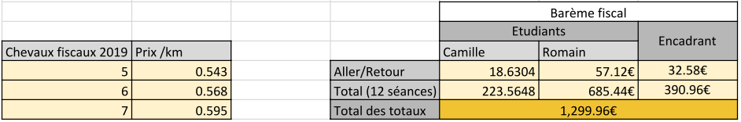

After that, we had to calculate the costs of the material that we are going to buy and rent, for a total of 2207.56+117 = 2324.56€.

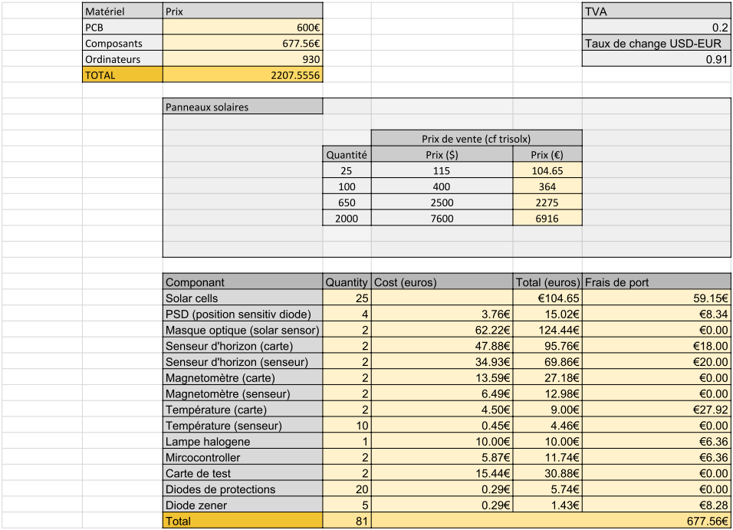

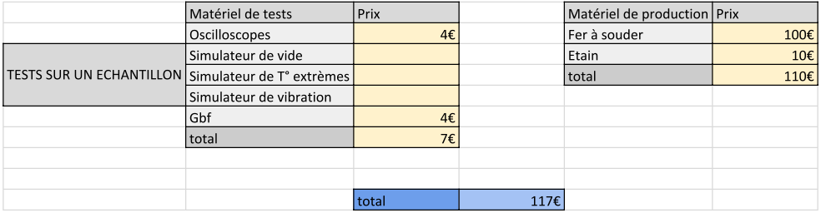



Finally, we arrived at a total of :

# 

# ARCHITECTURE

## A- Block Diagram

## B- Description

The circuit board will be organized into four different parts. Every part has its own purpose and they are all interacting with each other.

### The solar panel

The first and most important part of our project is the solar panel. Indeed, it is the heart of our mission. The panel will be “intelligent”, meaning it will be able to self maintain itself. In fact, we will do voltage and current measures to check if the cells are furnishing what we need to power the whole satellite for example, or if one or several cells need to be disconnected if they are no longer working so that the circuit isn’t damaged. Moreover, we will monitor the temperature of the cells with temperature sensors.

### The sensors

This is the second most important part of our project. It includes three different captors. They will be able to calculate the satellite’s orientation in space, thanks to three vectors calculated with the orientation to the sun, to the earth’s horizon, and to the earth’s magnetic field. As mentioned previously, there will also be a temperature sensor and a multimeter.

### The microcontroller

The microcontroller’s duty is to process all the data sent by the sensors and send them to the central unit of the nanosatellite.

### The alimentation

This part would be the batteries, charged by our solar panel. However, we are not in charge of the batteries part. We just need to supply enough power to be able to charge them.

# IV REALISATION

## A - Solar cells

## B - Microcontroller and sensors interfacing

## 

# ORGANIZATION

To organize our project, we used a software named Gantt. It assigns a “Ressource” (student) to every task.

## A- Tasks description

The first semester is made of six weekly courses of 3 hours and 6 hours for the second semester, but we assumed we would also work during our free time. We created thirteen different tasks to execute in the first semester, and sixteen in the second. All these tasks are described in the Gantt diagram below.

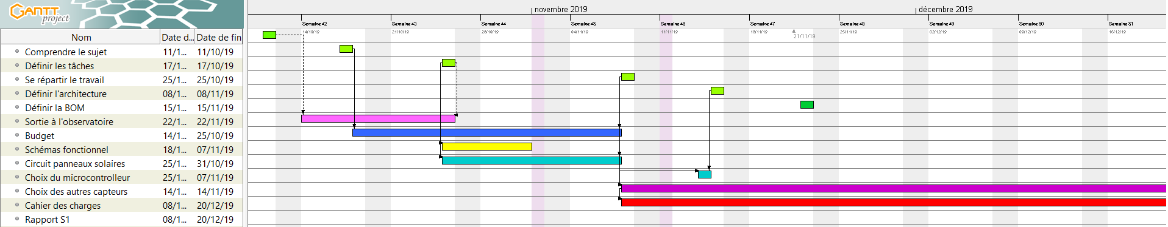

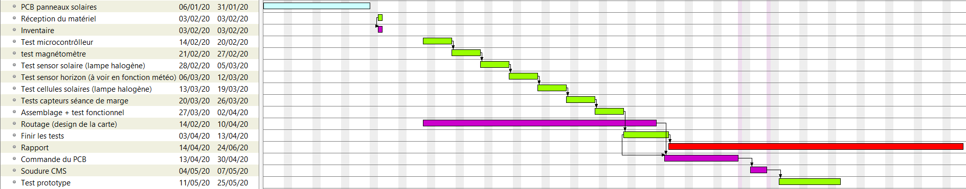

## B- Tasks repartition

We estimated the tasks repartition following, for the second semester, but it is likely to change.





# BOM

Finally, after having fully analyzed our project’s specifications, we made a Bill Of Material (BOM), including all the material that we will need to realize the project.

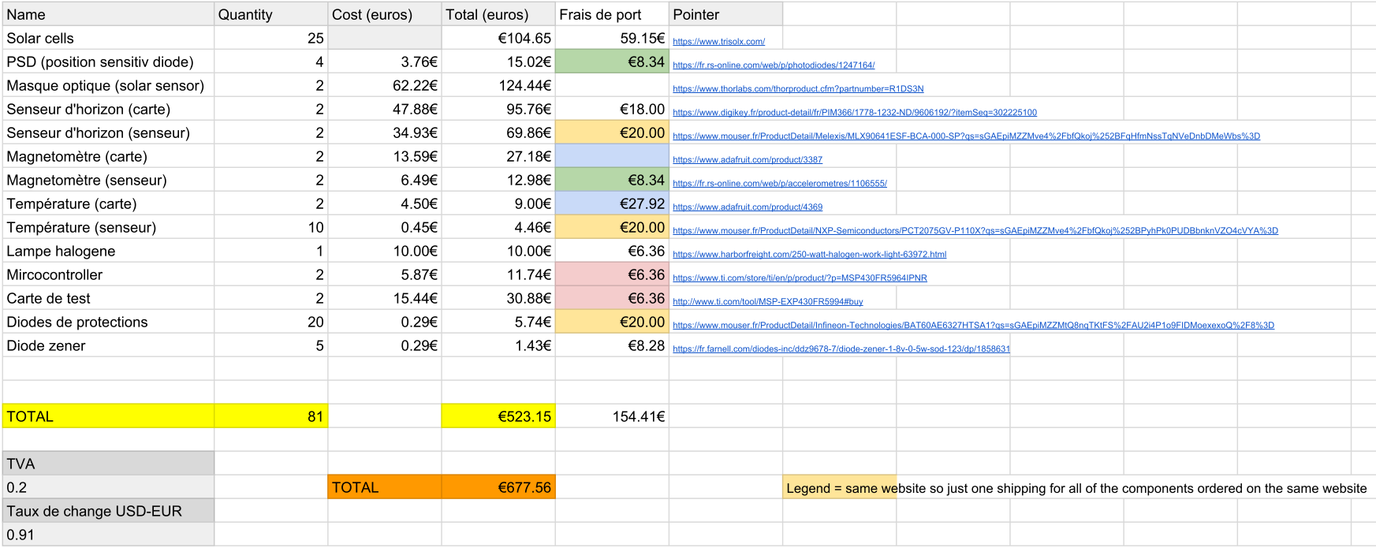

# ANNEXE